**SOLUTION ARCHITECTURE**

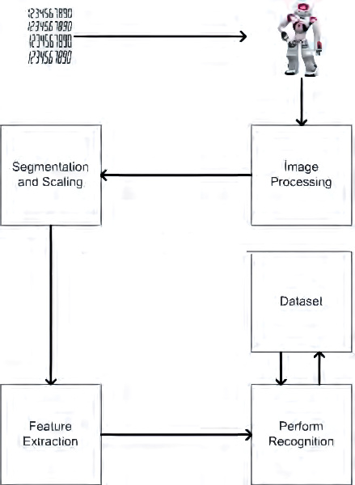

MNIST dataset processing with python

